**Getting & Setting HTML Objects**

These properties are used to get Html elements and other things like: Domain, URL, Cookies…..

|  |  |  |
| --- | --- | --- |
| **Property** | **Description** | **DOM level** |
| **document.anchors** | Returns all <a> elements that have a **name** attribute | 1 |
| **document.links** | Returns all <area> and <a> elements that have a **href** attribute | 1 |
| **document.documentElement** | Returns the <html> element | 3 |
| **document.doctype** | Returns the document's doctype | 3 |
| **document.URL** | Returns the complete URL of the document | 1 |
| **document.documentURI** | Returns the URI of the document | 3 |
| **document.baseURI** | Returns the absolute base URI of the document | 3 |
| **document.domain** | Returns the domain name of the document server | 1 |
| **document.forms** | Returns all <form> elements | 1 |
| **document.title** | Returns the <title> element | 1 |
| **document.head** | Returns the <head> element | 3 |
| **document.body** | Returns the <body> element | 1 |
| **document.images** | Returns all <img> elements | 1 |
| **document.embeds** | Returns all <embed> elements | 3 |
| **document.cookie** | Returns the document's cookie | 1 |
| **document.documentMode** | Returns the mode used by the browser | 3 |
| **document.domConfig** | Obsolete. Returns the DOM configuration | 3 |
| **document.implementation** | Returns the DOM implementation | 3 |
| **document.inputEncoding** | Returns the document's encoding (character set) | 3 |
| **document.lastModified** | Returns the date and time the document was updated | 3 |
| **document.readyState** | Returns the (loading) status of the document | 3 |
| **document.referrer** | Returns the URI of the referrer (the linking document) | 1 |
| **document.scripts** | Returns all <script> elements | 3 |
| **document.strictErrorChecking** | Returns if error checking is enforced | 3 |
| **document.applets** | Returns all <applet> elements **(Deprecated in HTML5)** | 1 |

**Note:** All these properties can be **set** by using **property = ‘new value’**

1. **document.images**

This property is used to get <img> elements present on HTML document.

**Example:**

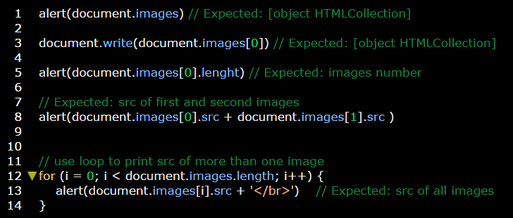

1. **document.forms**

This property is used to get all <form> elements present on HTML document through its **name**.

**Example:**

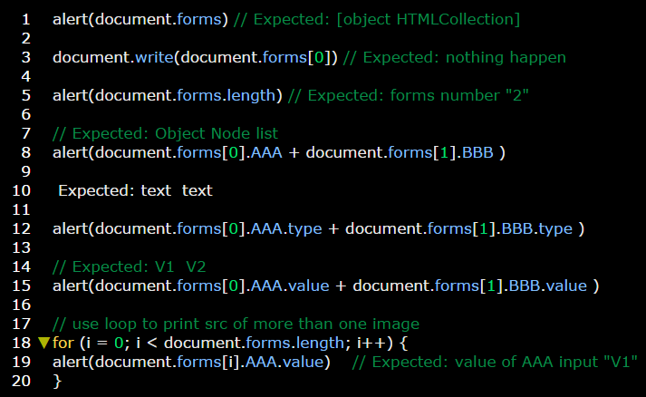

**Examples:**

